

August Real Estate

Commercial Insurance PROPOSAL

Presented by: Rick Crain Jr.  
rcrain@swinglecollins.com

(214) 789-7894

13760 Noel Road, Suite 600

Dallas, TX 75240

Table of Contents

Why Choose Swingle Collins? 3

Your Trusted & Knowledgeable Advisors 4

Expo Park Insurance Renewal Summary 5

Property 6-14

Property Terrorism & Equipment Breakdown 15

General Liability 16

Workers Compensation 17

CGB, Lakewood Tower, & 333 1st Ave Program Analysis 18-19

Next Steps 20

We’re Here for You 24/7 21

Why Choose Swingle Collins?

As one of the largest privately-owned insurance agencies in Texas, Swingle Collins & Associates is able to provide solutions for even the most unique and complex risks. Our status as an independent firm allows us to offer the type of tailored service and coverage options that our clients both expect and deserve.

Because of our growth, success and level of service, leading carriers have awarded us top-tier access, which directly benefits our clientele with a broader range of choices and services. By adopting a consultative approach and staying at the forefront of emerging trends, we’re able to deliver options that are selected specifically to ensure that your business, assets, family, and employees have the level of coverage they need.

Our elite team of risk advisors is considered best-in-class by industry peers and clients alike. We’ve been named a Top 100 Independent Property/Casualty Agency by *Insurance Journal* and rated among the “Best Places to Work” by *Insurance Journal* and the *Dallas Business Journal*.

In everything we do, we strive to be an extension of your company and family wealth management team, providing you with the peace of mind that your assets are properly protected — and that your needs will always come first.

Your Trusted & Knowledgeable Advisors

|  |  |  |
| --- | --- | --- |
|  |  | Personal Risk Advisor |
|  |  | *Your coverage expert and partner.* |
|  |  | **Rick Crain Jr.** |
|  |  | (214) 789-7894 |
|  |  | [rcrain@swinglecollins.com](mailto:rcrain@swinglecollins.com) |
|  |  |  |

|  |  |  |
| --- | --- | --- |
|  |  | SWINGLE COLLINS SHAREHOLDER |
|  |  | *Your coverage expert and partner.* |
|  |  | **Kyle Cardwell** |
|  |  | (972) 814-3688 |
|  |  | [kcardwell@swinglecollins.com](mailto:kcardwell@swinglecollins.com) |

|  |  |  |
| --- | --- | --- |
|  |  | Account Manager |
|  |  | *Provides support for claims, billing, and coverage questions.* |
|  |  | **Susan Murphy** |
|  |  | (972) 715-8766 |
|  |  | [smurphy@swinglecollins.com](mailto:smurphy@swinglecollins.com) |
|  |  |  |

|  |  |  |
| --- | --- | --- |
|  |  | Claims |
|  |  |  |
|  |  | **Cheryl Murphy**  (972) 387- 6702 |
|  |  | [services@swinglecollins.com](mailto:services@swinglecollins.com) |
|  |  |  |

Expo Park Insurance Renewal

| **Coverage** | **Expiring\*\*** | **Renewal** |
| --- | --- | --- |
| Property  *Total Values* | $357,735.00  *$46,847,553* | $312,025.90  *$46,384,891* |
| Property Terrorism | $6,324.00 | $4,197.53 |
| Equipment Breakdown | $3,731.00 | $2,463.00 |
| General Liability  *Units* | $50,103.00  *234* | $30,498.00  *234* |
| Workers’ Compensation & Employers Liability  *Total Payroll* | $8,362.00  *$463,520* | $7,279.00  *$1,621,776* |
| ***Total*** | ***$426,255.00*** | ***$356,463.43*** |
| ***Premium Change ($)*** |  | $69,791.57 |
| ***Premium Change (%)*** |  | 16.4% |





Property Summary



Property – $5M Primary

|  |  |
| --- | --- |
| **Issuing Company** | **Ambris (Aegis) – 88.5% of $5M Primary** |
| **Policy Term** | **06/23/2024 to 06/23/2025** |
| **Named Insured** | **August Real Estate Co** |

| Coverage part | amount |
| --- | --- |
| Total Insured Values | $46,384,891.00 |
| Premium | $181,078.08 |
| Property Rate | $0.39 Per $100 in Values |

|  |  |
| --- | --- |
| **Issuing Company** | **Ambris (Aegis) – 11.5% of $5M Primary** |
| **Policy Term** | **06/23/2024 to 06/23/2025** |
| **Named Insured** | **August Real Estate Co** |

| Coverage part | amount |
| --- | --- |
| Total Insured Values | $46,384,891.00 |
| Premium | $25,859.82 |
| Property Rate | $0.06 Per $100 in Values |

| Coverage part | amount |
| --- | --- |
| AOP Deductible | $250,000 |
| Water Damage Deductible | $250,000 |
| Wind / Hail Deductible | 3% Subject to a $250,000 Minimum |
| Named Windstorm – Tier 1 Counties | 5% Subject to a $250,000 Minimum |
| Flood Coverage | $1,000,000 Subject to $250,000 Deductible |
| Earthquake Coverage | $1,000,000 Subject to $250,000 Deductible |

Property – $5M Excess $5M Primary

|  |  |
| --- | --- |
| **Issuing Company** | **Kinsale Insurance Company** |
| **Policy Term** | **06/23/2024 to 06/23/2025** |
| **Named Insured** | **August Real Estate Co** |

| Coverage part | amount |
| --- | --- |
| Total Insured Values | $46,384,891.00 |
| Premium | $47,618.00 |
| Property Rate | $0.10 Per $100 in Values |
| Deductibles Follow Ambris Primary |  |

Property – $36,384,891 Excess $10M

|  |  |
| --- | --- |
| **Issuing Company** | **Palomar Excess and Surplus Insurance Company** |
| **Policy Term** | **06/23/2024 to 06/23/2025** |
| **Named Insured** | **August Real Estate Co** |

| Coverage part | amount |
| --- | --- |
| Total Insured Values | $46,384,891.00 |
| Premium | $57,470.00 |
| Property Rate | $0.12 Per $100 in Values |
| Deductibles Follow Ambris Primary |  |





Property Terrorism

|  |  |
| --- | --- |
| **Issuing Company** | **Certain Underwriters at Lloyd’s of London** |
| **Policy Term** | **06/23/2024 to 06/23/2025** |

| Premium | premium basis | rate |
| --- | --- | --- |
| $4,197.53 | 46,384,891.00 | $0.009 |

Equipment Breakdown

|  |  |
| --- | --- |
| **Issuing Company** | **Travelers (The Phoenix Insurance Company)** |
| **Policy Term** | **06/23/2024 to 06/23/2025** |

| Premium | premium basis | rate |
| --- | --- | --- |
| $2,463.00 | 46,384,891.00 | $0.005 |

General Liability

|  |  |
| --- | --- |
| **Issuing Company** | **Falls Lake Fire and Casualty Company (Paragon)** |
| **Policy Term** | **06/23/2024 to 06/23/2025** |
| **Named Insured** | **August Family Investments, LTD** |

| Premium | premium basis | rate |
| --- | --- | --- |
| $30,498.00 | 234 Doors | $130.33 |

Coverages

|  |  |
| --- | --- |
| Description | Limit |
| General Aggregate (Location) | $2,000,000 |
| Products / Completed Operations Aggregate | $2,000,000 |
| Each Occurrence | $1,000,000 |
| Personal and Advertising Injury | $1,000,000 |
| Damage to Premises Rented to You | $100,000 |
| Medical Expense (Any One Person) | Excluded |
| Assault & Battery Sublimit | $1,000,000 / $1,000,000 |
| Policy Aggregate | $10,000,000 |
| Deductible | $25,000 Per Occurrence |



Comments

* Crum & Forster (Renewal) – Exclusion: Designated Ongoing Operations And Designated Work
* Crum & Forster – Expiring Policy Aggregate was only $5,000,000, Renewal Dropped the Policy Aggregate
* Paragon – Exclusion: Residential Conversion

Workers Compensation

|  |  |
| --- | --- |
| **Carrier** | **The Hartford** |
| **Policy Term** | **06/23/2024 to 06/23/2025** |
|  |  |
| **Named Insured** | **August RE Services Inc** |

| Premium | premium basis | rate |
| --- | --- | --- |
| $7,279.00 | $1,621,776.00 Payroll | $0.45 |

| Employer’s Liability | |
| --- | --- |
| Bodily Injury by Accident, Each Accident | $1,000,000 |
| Bodily Injury by Disease, Each Employee | $1,000,000 |
| Bodily Injury by Disease, Policy Limit | $1,000,000 |

PREMIUM BASIS

| State | Code | Classification Description | Estimated Annual Payroll |
| --- | --- | --- | --- |
| TX | 9032 | Apartment House Operations | $742,196 |
| TX | 8809 | Executive Officers NOC | $124,800 |
| TX | 8810 | Clerical Office Employees NOC | $754,780 |
| *Total Payroll* | | | *$1,621,776* |



CGB, Lakewood Tower, & 333 1st Ave Program Analysis



Comments

* Property – Rate may be able to be improved, currently seeing $0.15 – $0.25 for Office
* Property – 6301 Gaston Ave, Roof is Actual Cash Value (ACV)
* **General Liability – Exclusion: Construction Operations Exclusion**
* General Liability – Continuous Or Progressive Injury and Damage Exclusion
* General Liability – Exclusion - Condominium, Townhouse And Cooperative Housing Conversion
* **General Liability – Assault & Battery Coverage Limitation**
* General Liability – Exclusion - Bodily Injury to Leased Workers & Temporary Workers
* General Liability – Special Conditions for Subcontractors Including Deductible
* General Liability – Special Exclusion With A Limited Bodily Injury Exception

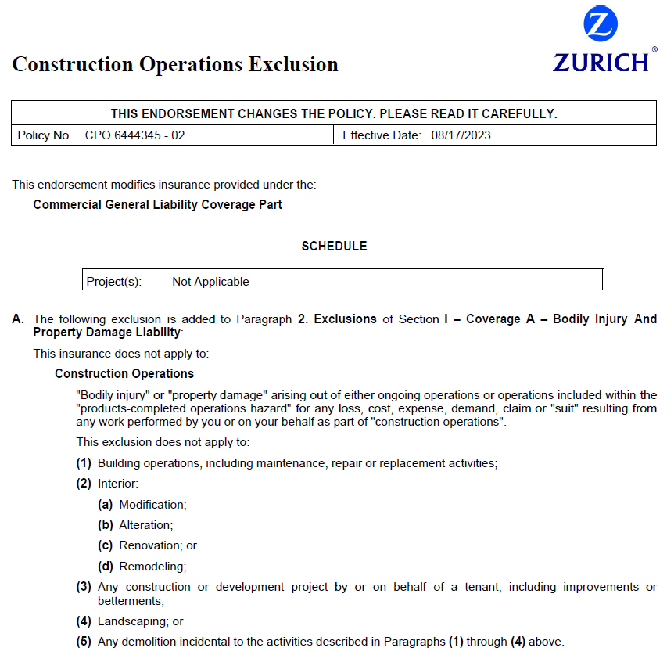

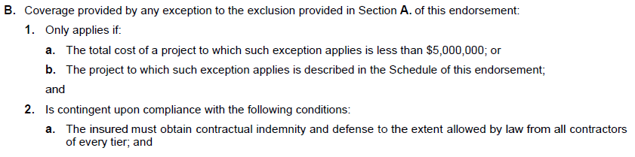

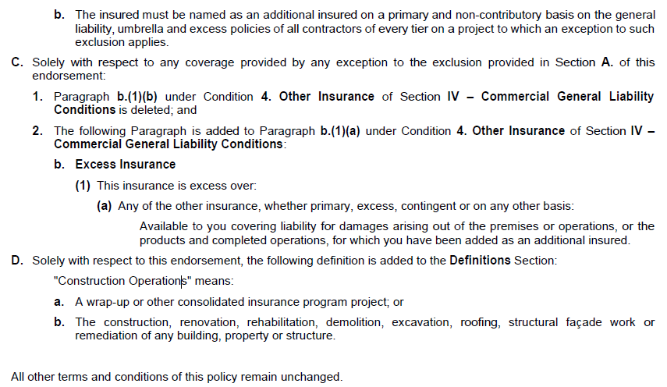

Next Steps

* **Items Needed to Bind Coverage**
  + **Property**
    - **Ambris Quotes (2x) – Written Request to Bind, Signed TRIA Forms, Loss Runs**
    - **Kinsale Quote – Written Request to Bind, Signed TRIA Forms, 5 Years of Loss Runs Valued Within 60 Days of Inception**
    - **Palomar – Written Request to Bind, Signed TRIA Forms**
  + **Property Terrorism – Written Request to Bind**
  + **Equipment Breakdown – Written Request to Bind**
  + **General Liability – Acord 68, COI with Hold Harmless & AI Status, Signed Surplus Lines Form, Copy of Formal Safety Program, Favorable Loss Control Inspection, Signed Acord Apps, Signed Supplemental Application, 5 Years of Loss Runs Valued Within 60 Days of Inception, Signed TRIA Form**
  + **Workers Compensation – Written Request to Bind**
* **Payment – Discuss How to Invoice for Southside Bank and August RE Services, Inc**
  + **Pure Premium vs. Agent/Broker Fees**
* **Once Policies are Bound & Released – Swingle Collins Team to Issue New Evidence of Property Insurance and Certificate of Insurance**
* **Full Policy Documents Will Be Sent Once Received**
  + **Discuss Enrollment in SCA Client Portal**
* **CGB, Lakewood Tower, & 333 1st Ave – Execute Agent of Record Letters**
  + **Start Gathering SOV, Loss Runs, & Additional Underwiring Info for 8/17/24 Renewal**

We’re Here for You 24/7

We place a high priority on providing superior service, and on being there for you whenever you need us. We’re always happy to take your calls, answer emails and resolve any issues during standard business hours. Outside office hours, we make it easy to get the information you need with 24/7 account access through your computer or device.

Whether at your office, at home, or on the road you can log into your account anytime, anywhere to:

* Review your coverage and current policy information.
* Request changes to your policies or contact information.
* Create and send certificates of insurance and auto ID cards on demand.
* Report a claim or loss

Your time is valuable. Our goal is to help you quickly and easily get the information or resources you need, whether you’re dealing with us in person, on the phone or online

